**Embedded System: The Good and the Bad**

***Table of Contents Pages***

*Introduction…………………………………………………………………..(1)*

*Nix Embedded OS……………………………………………………………(2)*

*Vulnerabilities of Embedded Systems……………………………………...(2-3)*

*Why is the security of embedded systems neglected?…………………….(3)*

*Advantages of using Embedded Systems……………………………………(4)*

*Disadvantages of using Embedded Systems…………………………………(4)*

*Citations………………………………………………………………………….(5)*

Daniel Rao

March 21, 2021

Vince

**Introduction**

An embedded system is any computer system that isn't really a general purpose computer or a server. In addition to GPS devices and some ATMs embedded systems are also found in a wide variety of electronic consumer and Industrial items such as toys kitchen appliances printers industrial Control Systems, spacecrafts, airplanes and tons of scientific equipment. An embedded operating system can be a small program developed specifically for the use with embedded systems or it can be a stripped-down version of an OS commonly used on general-purpose computers. Embedded os are usually designed to be small and efficient so they don't have some of the functions that general-purpose OS do. also they don't offer creatures that most general purpose computers do as part of their package. one type of embedded OS is a real-time operating system which is typically used in devices such as programmable thermostats, appliances control, and spacecraft.

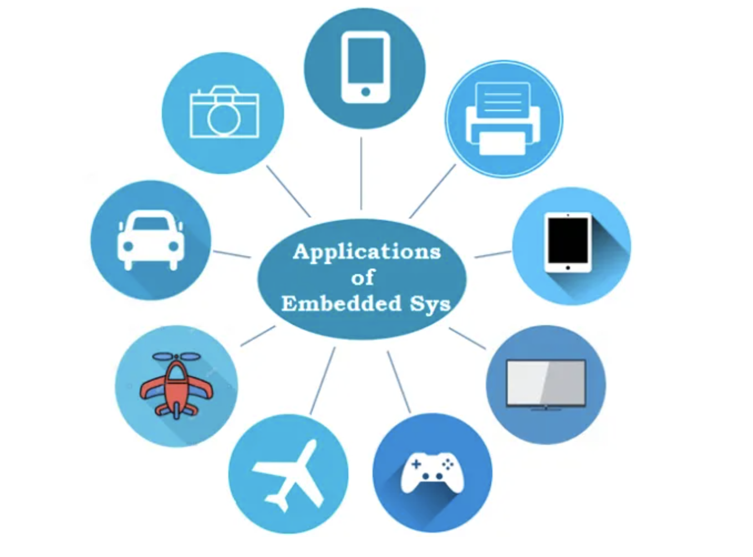

**Nix Embedded OS**

Embedded Linux is an example of an OS used in the multitude of industrial, Medical, and consumer items. And other operating systems can be tailored for devices with limited memory or hard drive capacity such as mobile phones. Is that it can support the widest variety of softwares and allows adding features by using Dynamic kernel modules. Other examples of her commercial products with linux-based OS’s are Cisco switches and routers, Garmin GPS devices and medical instruments.

**Vulnerabilities of embedded OS**

With our advancement in technology, embedded systems are getting really smart every single day, enabling us to get more things done then ever before. As more functionality are added to the devices there is an upsurge in security concerns as well. Device to add new features that often compromises with the basic security systems oh, that's making the devices more vulnerable to attacks.

One of the most famous embedded security breach was a TJX card breach which

Compromised 94 million credit and debit card numbers. an unknown number of intruders stored all this data from one of its systems over a period of more than 18 months later it was discovered that the reason for this breach wasn't insecure wireless network connection.

Another source tells us that there was a custom firmware for Sony PlayStation that had access to the developer only Network and allowed illegal operations. Austin time due to death a lot of multifunction printers have access to sensitive company data on many corporate Networks

In the past, there have been several of us structured attacks on various embedded devices, ranging from toasters to vehicle control systems. It was found that the majority of the embedded systems that are secured are using password protection and encryption protocols such as SSL or SSH, but apparently this by itself is not enough to make the devices secure.

The multiple layers of protection that includes encryption, authentication, Fireballs, security protocols, intrusion detection systems, and intrusion prevention systems to guard the company's data. Just by diss the embedded systems do not have firewalls and are only protected by the passwords in most of the cases bridge by itself is not enough

**Why is the security of embedded systems neglected?**

When it comes to security the majority of these devices are neglected as several assumptions are made which is that embedded systems are not vulnerable to cyber attacks. Another one is that embedded systems are not attractive targets for hacking., and that embedded systems get sufficient security bit encryption and Authentication. most of these assumptions are no longer valid as the number of embedded attacks has increased greatly therefore triggering a greater security measure required for embedded systems.

**Advantages of using embedded systems**

* they're convenient for mass production and because of that there are low price per piece.
* These systems are highly stable and reliable.
* This system is made to perform very specific tasks.
* The embedded systems are very small in size and therefore can be carried and loaded anywhere easily.
* It is faster and therefore they consume less power.
* The embedded systems improve the product quality.
* optimize the use of resources available.

**Disadvantages of using embedded system**

* once configured these systems are difficult to be changed or upgraded.
* the embedded systems are hard to maintain therefore it is difficult to take a backup offer embedded files.
* troubleshooting is difficult for embedded systems. transferring data from one system to another is also quite difficult as these systems are made for specific tasks and their Hardware is limited.
* they may not receive the updates as the way regular operating systems do. one of the reasons is that there may not be a community that supports it.

**Citations:**

<https://www.einfochips.com/blog/6-critical-challenges-facing-the-embedded-systems-security/>

<https://electricalfundablog.com/embedded-system-characteristics-types-advantages-disadvantages/>

<https://www.itrelease.com/2016/12/advantages-disadvantages-embedded-operating-system/>